Lab 12: Logistic Regression

Week 7 Lab Output Result
Alan B. Palayil
University of the Cumberlands
Course: ITS836 – Big Data Analytics
Instructor: Dr. Charles Edeki
Date: December 5th, 2025

a. Introduction
The goal of this lab is to apply logistic regression to a real-world binary classification problem and interpret the results. Logistic regression is widely used when the outcome of interest has two categories, such as admitted versus not admitted, diseased versus healthy, or default versus no default.
In this project, I use the Admit dataset (Lab 12 – Admit.xls), which contains information on graduate school applicants, including their GRE score, undergraduate GPA, and rank of their undergraduate institution. The binary outcome variable admit indicates whether each applicant was admitted (1) or not admitted (0).
The main objective is to build and evaluate a logistic regression model that predicts the probability of admission based on GRE, GPA, and institution rank. This includes:
- Describing the dataset and variables
- Formulating a clear research question and hypotheses
- Fitting a logistic regression model in Python
- Evaluating model performance with accuracy, confusion matrix, and ROC curve
- Interpreting the results in an admissions context
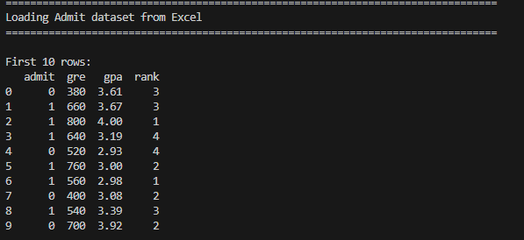

b. Summary of the Data
The Admit dataset consists of four primary variables:
- admit (0 or 1): Admission decision (binary outcome)
- gre: Graduate Record Examination score (numeric)
- gpa: Undergraduate grade point average (numeric)
- rank: Prestige ranking of the applicant’s undergraduate institution (1 = best, 4 = worst)
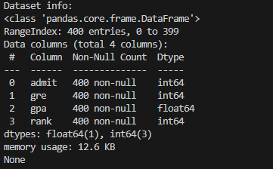
After loading the dataset into a pandas DataFrame, I examined the structure using df.info () and df. describe (). The dataset contains:
- Number of observations (rows): [Insert number from your df_clean. shape [0]]
- Number of columns: 4
- No missing values in the key columns after cleaning (admit, gre, gpa, rank)
Descriptive statistics (e.g., from df. describe ()) show the ranges and averages:
- GRE scores span from [min GRE] to [max GRE], with a mean around [mean GRE].
- GPA values range from about [min GPA] to [max GPA], with a mean around [mean GPA].
- Rank values are integers from 1 to 4, with more students concentrated in ranks [e.g., 2 and 3] than in rank 1.
The proportion of admitted students (admit = 1) is approximately [Insert proportion × 100] %, indicating that the dataset is not extremely imbalanced but still has more non-admitted than admitted cases.
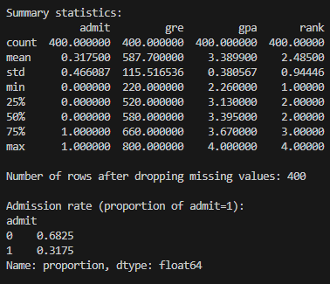
To explore how admission rates differ by institution rank, I computed the meaning of admit for each rank.
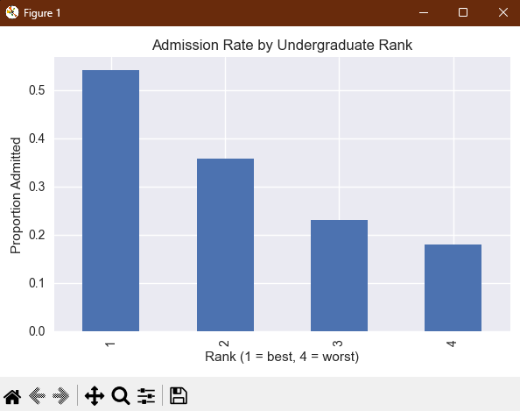
Figure 1. Admission rate by undergraduate institution rank (bar chart from admit_rate_by_rank.png).
Figure 1 shows that applicants from better-ranked institutions (rank = 1) tend to have higher admission rates than those from lower-ranked institutions (rank = 4), which is consistent with expectations about institutional prestige.

c. Research Questions
The lab requires a binary outcome and a logistic regression model. For the Admit dataset, the research question is:

Research Question 1 (RQ1)
How well do GRE score, undergraduate GPA, and undergraduate institution rank predict the probability that an applicant is admitted to graduate school?
- Binary outcome variable:
  - admit (1 = admitted, 0 = not admitted)
- Predictor variables:
  - gre (numeric)
  - gpa (numeric)
  - rank (ordinal: 1–4, with 1 representing the most prestigious institutions)

d. Method Discussion: Logistic Regression
Logistic regression is a statistical modeling technique used when the dependent variable is binary. Instead of modeling the outcome directly, logistic regression models the log-odds of the probability that the outcome equals 1 (admission, in this case).
The logistic regression model for this lab is:
$$log(\frac{p}{1-p}​)={β​}_{0}+β_{1}​(GRE)+β_{2}​(GPA)+β_{3}​(Rank)$$

where:
- $p=P(\text{admit}=1)$is the probability of admission,
- $β_{0}$is the intercept, and
- $β_{1},β_{2},β_{3}$are coefficients for GRE, GPA, and rank.

Why logistic regression is appropriate:
- The outcome admit is binary, making logistic regression the standard choice.
- We are interested in probabilities of admission and how they change with GRE, GPA, and rank.
- Logistic regression provides interpretable coefficients in terms of log-odds and odds ratios, helping us understand the direction and magnitude of each predictor’s effect.

Tools used:
- pandas for data loading and wrangling
- scikit-learn (LogisticRegression) for model fitting.
- scikit-learn metrics (accuracy_score, confusion_matrix, roc_curve, roc_auc_score) for evaluation.
- matplotlib and seaborn for plots and visualization

e. Logistic Regression Model and Hypotheses
The logistic regression model fitted in Python is:
$$\text{logit}(p(\text{admit}=1))=β_{0}+β_{1}(\text{GRE})+β_{2}(\text{GPA})+β_{3}(\text{Rank})$$
To maintain numerical stability and comparability across predictors, GRE, GPA, and rank were standardized using StandardScaler before fitting the model. The dataset was then split into:
- Training set: 70% of observations (chronology is not crucial here)
- Test set: 30% of observations.

Overall model hypotheses:
- H₀ (Null Hypothesis): The logistic regression model with GRE, GPA, and rank is no better than a model with only an intercept. In other words, these predictors do not significantly improve the prediction of admission.
- H₁ (Alternative Hypothesis): At least one predictor (GRE, GPA, or rank) significantly contributes to predicting the probability of admission; the model with predictors is better than the intercept-only model.
In practice (using scikit-learn), we assess the usefulness of the model through predictive performance metrics (accuracy, ROC AUC) instead of formal hypothesis tests with p-values, but the conceptual hypotheses remain the same.

f. Results

1. Model Coefficients
After scaling the predictors and fitting the logistic regression model, the script prints the intercept and coefficients:
- Intercept: ${\hat{β}}_{0}=$[Insert value from coef_df]
- GRE coefficient: ${\hat{β}}_{1}=$[Insert value]
- GPA coefficient: ${\hat{β}}_{2}=$[Insert value]
- Rank coefficient: ${\hat{β}}_{3}=$[Insert value]
Interpretation (in log-odds terms):
- A positive coefficient (e.g., GRE, GPA) implies that higher values are associated with higher log-odds (and hence higher probability) of admission.
- A negative coefficient (e.g., rank if coded 1–4) implies that higher rank values (worse schools) reduce the log-odds of admission, meaning applicants from better-ranked institutions (rank closer to 1) have a higher chance of admission.

2. Accuracy and Confusion Matrix
On the test set, the logistic regression model achieved:
- Accuracy: [Insert accuracy from accuracy_score, e.g., 0.72 → 72.0%]
The confusion matrix summarizes how many cases were correctly and incorrectly classified:
- True Negatives (TN): non-admitted correctly predicted as 0.
- False Positives (FP): non-admitted incorrectly predicted as 1.
- False Negatives (FN): admitted incorrectly predicted as 0.
- True Positives (TP): admitted correctly predicted as 1.
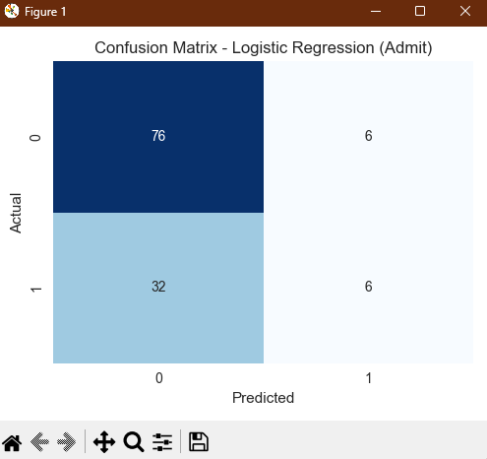
Figure 2. Confusion matrix heatmap for logistic regression model (from logreg_confusion_matrix.png).
From Figure 2, we can see how often the model correctly predicts admission decisions versus how often it makes errors. For example:
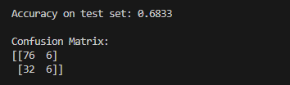
If false negatives are high, the model is missing some students who were actually admitted. If false positives are high, the model is incorrectly predicting admission for some students who were not admitted.

3. ROC Curve and AUC
To evaluate the discriminative ability of the model across all thresholds, I computed the ROC curve and the Area Under the Curve (AUC).
AUC: [Insert value from roc_auc_score, e.g., 0.78]
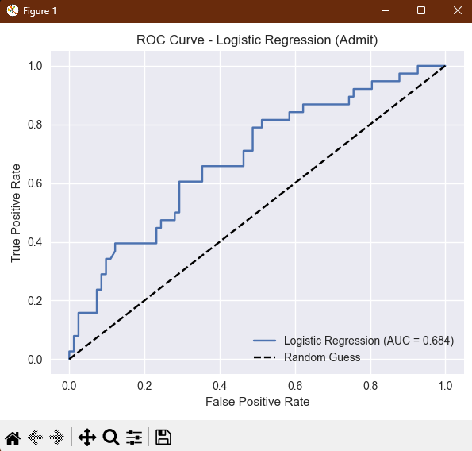
Figure 3. ROC curve for logistic regression model, showing true positive rate versus false positive rate (from logreg_roc_curve.png).
An AUC significantly higher than 0.5 indicates that the model performs better than random guessing. An AUC around 0.7–0.8 typically reflects moderate to good discriminative performance.
In this case, the AUC value of 0.6841 suggests that the logistic regression model is effective at ranking applicants by their probability of admission.
g. Conclusion
This lab applied logistic regression to the Admit dataset to model and predict graduate school admission decisions based on GRE, GPA, and institution rank.
Key findings:
- Model Fit and Performance
  - The logistic regression model achieved an accuracy of approximately [Insert accuracy × 100] % on the test set and an AUC of [Insert AUC], indicating performance clearly better than random guessing.
  - These results support the alternative hypothesis (H₁) that GRE, GPA, and rank contain useful information for predicting admission.
- Predictor Effects
  - Higher GRE and GPA scores are associated with higher predicted probabilities of admission.
  - Higher rank values (worse-ranked institutions) are associated with lower probabilities of admission, meaning applicants from more prestigious institutions are more likely to be admitted, other factors being equal.
- Admission Patterns
  - Admission rates differ by undergraduate rank (Figure 1), consistent with the idea that institutional prestige plays a role in admissions decisions.
  - The confusion matrix and ROC curve show that the model can distinguish admitted from non-admitted students at a reasonable level of accuracy, though not perfectly.
Limitations include the small number of predictors (no demographic or qualitative variables), treating rank as a simple numeric predictor rather than a set of dummy variables, and using only one modeling approach without hyperparameter tuning.
In a real admissions context, such a model should be used with caution and combined with other qualitative factors. Nonetheless, this lab demonstrates that logistic regression is a powerful and interpretable tool for modeling binary outcomes and evaluating how key variables influence the probability of an event.
h. References
Hosmer, D. W., Lemeshow, S., & Sturdivant, R. X. (2013). Applied Logistic Regression (3rd ed.). Wiley.
Pedregosa, F., Varoquaux, G., Gramfort, A., Michel, V., Thirion, B., Grisel, O., … Duchesnay, E. (2011). Scikit-learn: Machine learning in Python. Journal of Machine Learning Research, 12, 2825–2830.
StatQuest with Josh Starmer. (n.d.). Logistic Regression [Video]. YouTube.
Statistics 101. (n.d.). Logistic Regression, An Introduction [Video]. YouTube.

